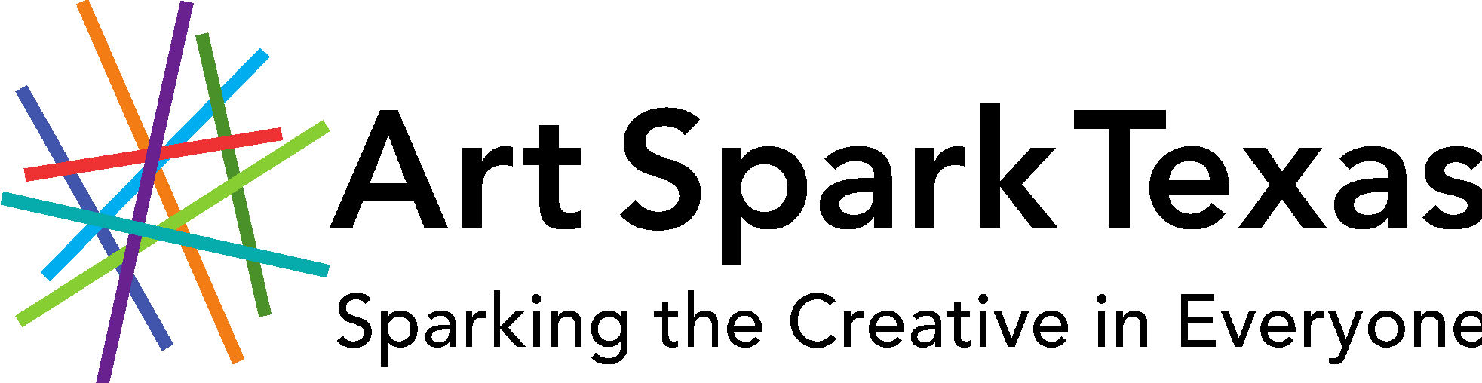

2021 Art Spark Texas
Annual Artist of the Year Awards
- Haven Street-Allen Artist of the Year Award
- Lynn Marie Johnson Media Arts Award
- SPARK Award
- Mobile Art Award

Nomination Deadline: Friday, April 16, 2021

Art Spark Texas annually honors artists in the field of visual art, dance, music, performance, craft, media and writing. Each year, the Artist of the Year Awards are given to Texas artists who embody the spirit and vision of Art Spark Texas, and who challenge the perceptions of how people contribute by demonstrating artistic excellence or leading the way as a community catalyst for change.

Self-nominations are allowed, as well as multiple nominations for one individual.

The Haven Street-Allen Artist of the Year Award is named for former Board member Forrest Haven Street-Allen and honors an established individual who has made an exceptional contribution to affirming that the power of an artistic spirit, combined with determination and will, can influence and shape our society. Each year, the award is given to an artist with a disability in Texas who, through a one-time creative act or a substantial record of achievement, embodies the vision of Art Spark Texas.

The Lynn Marie Johnson Media Arts Award is named for former staff member Lynn Marie Johnson and honors her unwavering advocacy for artists with diverse abilities in media. The award is given to a Texas artist who displays passion and commitment to the promotion and awareness of people with disabilities in the media arts, (i.e, video, film, photography, television, radio, social media, etc.) as producer, artist, writer, etc. or any combination.

The SPARK Award is given to an emerging Texas artist with a disability who embodies the infective and innovative spirit of Art Spark Texas. Nominations are open to any individual over the age of 16 years in any discipline, including visual art, dance, music, performance, craft, media and writing.

The Mobile Art Award is named in tribute to Theresa Zelanzy for her devotion to her mother and all creative older adults. It is given to a Texas artist age 65 or older, who exemplifies the creative aging philosophy that engagement in the arts improves emotional well-being, supports good health, strengthens social bonds, and brings a heightened experience of purpose and joy. Visual artists who work in 2-dimensional and 3-dimensional, as well as fiber artists, are eligible.

Each award includes an honorarium and an invitation to attend our annual event as a guest of honor to be publicly recognized for their achievements.

A panel of judges will jury nominations and the results will be announced in July 2021.

All nominations must be in by April 16, 2021 to be considered for the award.

Winners announced July 2021

The award ceremony will be in September 2021 in Austin, Texas.

For more information call (512) 454-9912 or toll free 1-866-489-8412.

Submit Applications:

email info@artsparktx.org

Mail: Art Spark Texas
3710 Cedar Street Box #7
Austin, Tx 78705

Nomination Form
Art Spark Texas Artist of the Year Awards
Application Due: April 16, 2021

NOMINATOR INFORMATION

Nominated by: ____________________________________

Phone number: ___________________________________

Email address: ____________________________________

Street Address: ____________________________________

City: _______________ State: ________ZIP code: ________

NOMINEE INFORMATION
please select an award category:

__ Haven-Allen Artist of the Year
__Lynn Marie Johnson Media Arts Award

__SPARK Award

__Mobile Art Award

Nominee: ____________________________________

Phone number: ___________________________________

Email address: ____________________________________

Street Address: ____________________________________

City: _______________ State: ________ZIP code: ________

Website (if available): _______________________________
Use additional paper if necessary. (please include samples or links to the artists work).

- Please describe the nominee and why he, she or they are deserving of this award.

- Please list links to or include copies of artist press coverage, social media links, blogs, interviews if available.

- What exhibitions/performances/events has the artist participated in? Please include location and date.

- Please describe what you believe to be the nominee’s substantial artistic achievements.

- What is the significant artistic or community impact of the nominee’s artistic work?

- Has this artist’s work inspired a catalyst for change in their community? If so, please tell us a little about it.

- How did you discover the nominee’s work?

- How do you know the nominee?

- Can we contact you if we need additional information? Yes___ No___

- Do you wish this nomination to be anonymous?

Yes___ No___

Please attach photos or a link to the artist’s work to nomination form.

SUBMIT NOMINATION FORM VIA EMAIL info@artsparktx.org OR Mail:

2021 Artist of the Year Nomination
Art Spark Texas
3710 Cedar Street, Box #7
Austin, Texas 78705

