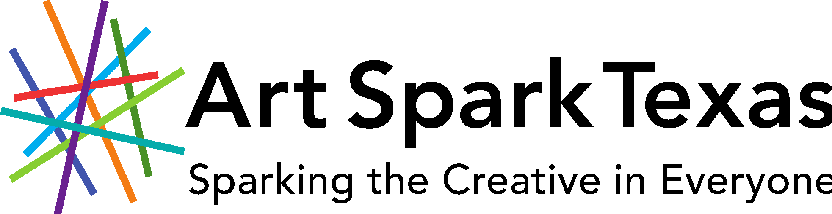

2022 Art Spark Texas Annual Artist of the Year Awards
- Haven Street-Allen Artist of the Year Award
- Lynn Marie Johnson Media Arts Award
- SPARK Award
- Gloria Bond Creative Aging Award

Nomination Deadline: Friday, April 30, 2022

Art Spark Texas annually honors artists in the field of visual art, dance, music, theater, performance art, craft, media and writing. Each year, the Artist of the Year Awards are given to Texas artists who embody the spirit and vision of Art Spark Texas, and who challenge the perceptions of how people contribute by demonstrating artistic excellence or leading the way as a community catalyst for change.

Self-nominations are allowed, as well as multiple nominations for one individual.

The Haven Street-Allen Artist of the Year Award is named for former Board member Forrest Haven Street-Allen and honors an individual who has made an exceptional contribution to affirming that the power of an artistic spirit, combined with determination and will, can influence and shape our society. Each year, the award is given to an artist with a disability in Texas who embodies the vision of Art Spark Texas through a creative act(s) that has served as a catalyst for change for other individuals and their community.

The Lynn Marie Johnson Media Arts Award is named for former staff member Lynn Marie Johnson and honors her unwavering advocacy for artists with diverse abilities in media. The award is given to a Texas artist who displays Art Spark Texas passion and commitment to the promotion and awareness of people with disabilities in the media arts, (i.e, video, film, photography, television, radio, social media, etc.) as producer, artist, writer, director. etc., or any combination.

The SPARK Award is given to an emerging Texas artist with a disability who embodies the infectious and innovative spirit of Art Spark Texas. Nominations are open to any individual over the age of 16 years in any discipline, including visual art, dance, music, performance, craft, media and writing.

The Gloria Bond Creative Aging Award is named in honor of Mobile Art founder Theresa Bond Zelazny’s mother, a Texan who began her painting career after raising her family and who instilled her love for the visual arts in everyone she touched throughout her life. The award is given to a Texas artist aged 65 or older, who, through their body of work or demonstrated willingness to explore new art forms, exemplifies the active and creative aging philosophy of Art Spark Texas.

Each award includes an honorarium and an invitation to attend our annual event as a guest of honor to be publicly recognized for their achievements.

A panel of judges will jury nominations and the results will be announced in June 2022.

All nominations must be in by April 30, 2022 to be considered for the award.

Winners announced June 2022

The award ceremony will be in September 2022 in Austin, Texas.

Submit Applications:

email info@artsparktx.org

Mail: Art Spark Texas
1152 San Bernard
Austin, Tx 78702

Nomination Form
Art Spark Texas Artist of the Year Awards
Application Due: April 30, 2022

NOMINATOR INFORMATION

Nominated by: ____________________________________

Phone number: ___________________________________

Email address: ____________________________________

Street Address: ____________________________________

City: _______________ State: ________ZIP code: ________

NOMINEE INFORMATION
please select an award category:

__ Haven Street-Allen Artist of the Year
__Lynn Marie Johnson Media Arts Award

__SPARK Award

__Gloria Bond Creative Aging Award

Nominee: ____________________________________

Phone number: ___________________________________

Email address: ____________________________________

Street Address: ____________________________________

City: _______________ State: ________ZIP code: ________

Website (if available): _______________________________
Use additional paper if necessary. (please include samples or links to the artists work).

- Please describe the nominee, their artistic discipline, and why they are deserving of this award. *

- Please list links to, or include copies of, artist press coverage, social media links, blogs, interviews if available. *

- What exhibitions, performances, and/or events has the artist participated in? Please include location and date. *

- Please describe what you believe to be the nominee’s outstanding artistic achievements, or why you believe they should be honored by this award.

- Has this artist made an impact or inspired a catalyst for change in their community? If so, please tell us a little about it. *

- How did you discover the nominee and their work ?

- Can we contact you if we need additional information? Yes No

- Please provide names and contact information for at least three additional individuals who are familiar with the nominee’s work. We use these contacts to gather additional information as needed.

- Name: _________________________

Contact information (email and/or phone): __________________

- Name: _________________________

Contact information (email and/or phone): __________________

- Name: _________________________

Contact information (email and/or phone): __________________

- Do you wish this nomination to be anonymous?

Yes___ No___

* Important: Please include photos or a link to the artist’s work with the completed nomination form.

SUBMIT NOMINATION FORM VIA EMAIL info@artsparktx.org OR Mail:

2022 Artist of the Year Nomination to:
Art Spark Texas
1152 San Bernard Street
Austin, Texas 78702

