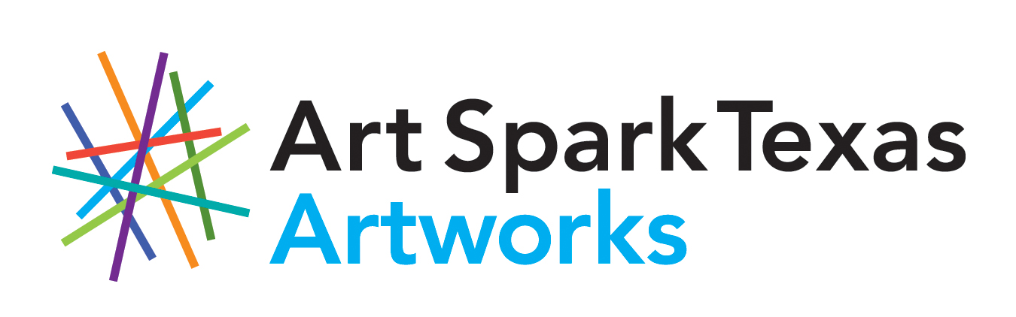

ENTRY FORM
Abilities Expo – Dallas, TX
December 11-13, 2020
Art Spark Texas Artist Market
DEADLINE: OCTOBER 9, 2020

Abilities Expo has invited Art Spark Texas to host the Artist Market at their event in Dallas. Art Spark Texas invites artists with disabilities living in the Dallas area to submit a booth proposal for the Artist Market at Abilities Expo 2020 in Dallas, TX. There is a $20 entry fee due with the application. If accepted into the show, there is a $25 booth fee. Splitting a booth with someone is allowed.

2D and 3D works in all media as well as crafts, literary arts, and CDs of music are eligible. Participants will be chosen by Art Spark Texas based on quality of work, the need to display diverse media, and ability of artist to be present and professional at this full weekend event.

Please submit this form with up to three examples of work to be in the form of digital photographs. The deadline for entry is Friday, October 9, 2020. Those selected will be notified by Friday, November 6, 2020.

The Artist Market will be on display during the Abilities Expo from December 11-13, 2020 at Dallas Market Center, 2100 Stemmons Freeway, Dallas, TX 75207.

Artist Name_____________________________________________

Address___________________________________________

City_________________ State____ Zip code____________

Telephone_________________________________________

E-Mail_____________________________________________

BOOTH PROPOSAL
Artists will be given space equivalent to a full 10’ x 10’ booth or can ask to share a booth as needed for the amount of art you have available for sale. Please describe the type of art you would like to sell, how many pieces you will have available, and any past experience you have with selling art from a booth at an art festival or other event.

________________________________________________________________________________________________________________________________________________________________________________________________________________________________________________________________________________________________________________________________________________________________________________________________________________________________________________________________________________________________________________________________

BOOTH SET-UP
Each booth will be provided with a six-foot table and two chairs. You are encouraged to use your own display panels, but some may be available for loan. Please describe the ideal set up for your booth. Maybe draw a picture if that is easier than a written explanation.

________________________________________________________________________________________________________________________________________________________________________________________________________________________________________________________________________________________________________________________________________________________________________________________________________________________________________________________________________________________________________________________________

BOOTH SITTING
Load in and out times are strict. Artists will have access to the loading dock, but not to hand trucks, dollies, or assistance. Artists must come prepared to move all of their own materials by hand or with their own 2-wheeled luggage cart.
Please indicate if the artist, or an artist representative, will be available for the following duties:

DUTY YES NO
- Load In & Set Up _____ ______
Thurs, Dec 10 2-4 pm and/or Fri, Dec 11 8am-10am
**No one under 18 yrs old may be on the floor during load in.
- Booth Sitting and Art Sales _____ ______
Fri, Dec 11 11am-5pm
- Booth Sitting and Art Sales _____ ______
Sat, Dec 12 11am-5pm
- Booth Sitting and Art Sales _____ ______
Sun, Dec 13 11am-4pm
- Load Out _____ ______
Sun, Dec 13 4pm-6pm
**No one under 18 yrs old may be on the floor during load out.

Each booth may have up to four sitters. All booth sitters must have a badge to enter the premises. Please provide names and email addresses of your booth sitters (including yourself if you will be in attendance).

NAME EMAIL
1. _____________________________ ____________________________
2. _____________________________ ____________________________
3. _____________________________ ____________________________
4. _____________________________ ____________________________

TERMS
The Abilities Expo is a large-scale event. They are giving Art Spark Texas a substantial discount to be an exhibitor and all artists exhibiting are doing so under the Art Spark Texas contract. We expect you to act professionally and courteously to all Expo staff and to go through Art Spark Texas for all questions and concerns. The rules and agreements to be allowed into this event are long. Below is a list of the few that pertain directly to you. Please check off each notification on the next page so that it is clear you have read each one.
- Art Spark Texas is the coordinator of the Artist Market at this event and will handle all sales and take a 30% commission from all artwork sold.
- Art Spark Texas and Abilities Expo Show Management reserve the right to define what constitutes an acceptable entry and booth display and may ask an artist to remove any materials that we determine, in our discretion, to be inappropriate.
- The artwork to be exhibited is the original artwork of the artist.
- No booth may exceed the 8-foot height limit.
- Show Management will provide 24-hour security guards at the event, but Abilities Expo is not responsible for loss or damages. We suggest you remove all small items from your booth each night.
- All sold items must be accompanied by a receipt. Art Spark Texas staff will be handling all sales and receipts.
- Art Spark Texas is providing insurance coverage for the Artist Market.
- No food or beverage samples are permitted to be dispensed at the booths without prior consent.
- No videotaping or photography except for of your own booth.
- Images of artwork submitted or photographs taken at the event by Art Spark Texas may be used for promotional purposes.
- Union Labor is required for this event, so individuals may not ask for assistance or to borrow equipment for load in and out. According to the show rules each person may only transport from the dock one trip by hand or on a two wheeled luggage cart. No dollies, hand trucks, or other mechanical equipment is allowed. Larger loads may be subject to a fee. (so please be discreet about your loads. We have never had a problem, but don’t want to start now. Ask me if you have any questions about this.)
- No storage of compressed gases at booths. No balloons are allowed.
- No animals allowed except service animals.
- Printed materials may be distributed at exhibitor booths, not in other parts of the hall.
- No storage allowed behind an exhibitor booth drape.
- We will not have electricity at our booth.
- Wifi and Parking Passes are available for a fee. Please ask for details.
- Do not respond to any outside company soliciting your business for the show directory or hotel arrangements for the Expo.

Please accept my work for consideration in the Artist Market at Abilities Expo 2020 in Dallas, TX. By applying to this exhibit, I agree and submit to all the terms outlined in the entry form.

Artist Signature____________________________________Date________________

ALL ENTRIES MUST BE SUBMITTED TO:
April Sullivan, Artworks Director
BY MAIL: Art Spark Texas 3710 Cedar Street #7, Austin, TX 78705
BY EMAIL: april@artsparktx.org OR BY FAX: 512-454-1944
Questions? Call April at 512-454-9912 or 866-489-8412

