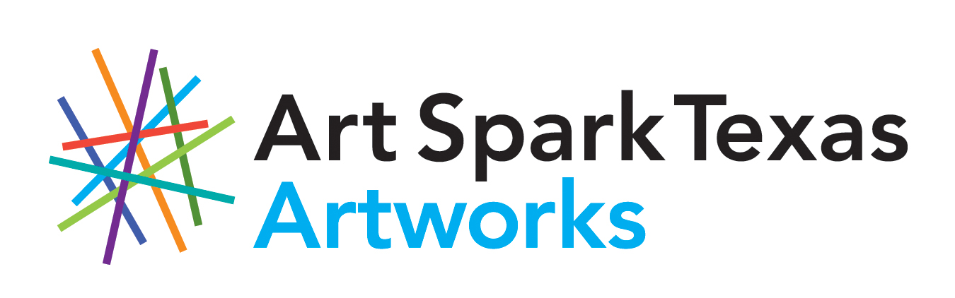

Call For Entries
Expressions 2020 Exhibition

Eligibility & Media
Art Spark Texas invites all artists ages 18+ in San Antonio and surrounding areas with a mental health diagnosis to submit artwork to the exhibition. There is no entry fee and 2D and 3D works in all media are eligible. Artwork may be no larger than 3’x3’. No negative images or images which are not suitable to be shown in the general public.

Entries
Please submit up to three entries in the form of photographs, digital images on CD, or by E-Mail. If you want your art considered for the postcard, send high quality images with no frame in the photo. The postmark deadline for entry August 10, 2020. In order to have images returned, send a self addressed, stamped envelope with the entry form. Those selected will be notified on August 21, 2020.

Exhibition
This annual exhibit will be on display during October 2020 at a gallery in San Antonio, Texas. Details on opening and closing date as well as reception and location will be available soon.

Terms
An entry to this exhibit constitutes full agreement on the part of the artist to all conditions outlined in this call for entries.
- Only entries submitted to the contact person below by the deadline will be considered for the exhibit.
- Work must be strongly framed with no plastic or damaged frames and artwork must properly fit in the frame provided.
- Secure wire for hanging must be on the back of all 2D artwork.
- No fragile or precious materials that cannot withstand normal handling will be accepted.
- The Exhibit Committee will have final authority to define an acceptable entry.
- All artists must be responsible for drop off and pick up.

Sales
A 30% commission will go to Art Spark Texas for all sales.

Calendar
August 10, 2020 Entry post mark deadline
August 21, 2020 Artist notified of acceptance
September 26, 2020 Accepted works due
October ??, 2020 Opening Reception
October ??, 2020 Show closes
For further information contact Susan Beattie at seabeattie@yahoo.com or
(210) 908-1776 or April Sullivan april@artsparktx.org or 512-454-9912.

REGISTRATION FORM
Art Spark Texas
Expressions 2020 Exhibition

Name__________________________Telephone____________

Address_____________________________________________

City_________________State______Zip Code______________

E-Mail________________________Alternate phone #________

- Please attach artist’s statement up to one page in length
- Please label each photograph or digital image with the corresponding entry from this form.

Entry #1

Title______________________________________________________________

Medium___________________________________________________________

Price________________________Frame size____________________________

Entry #2

Title______________________________________________________________

Medium___________________________________________________________

Price________________________Frame size____________________________

Entry #3

Title______________________________________________________________

Medium___________________________________________________________

Price________________________Frame size____________________________

Please accept my work for consideration in the Expressions Exhibit. By applying to this exhibit, I agree and submit to all the terms outlined in the call for entries.

Artist Signature____________________________________Date__________________

ALL ENTRIES MUST BE SUBMITTED TO:
Susan Beattie
5320 Blanco Rd. #1405, San Antonio, TX 78216
seabeattie@yahoo.com & april@artsparktx.org

