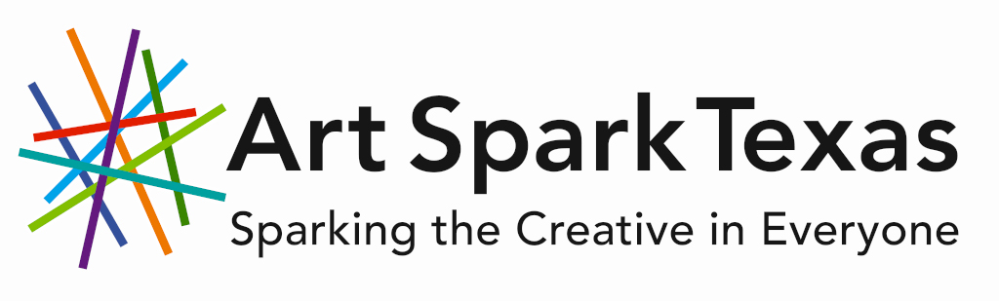
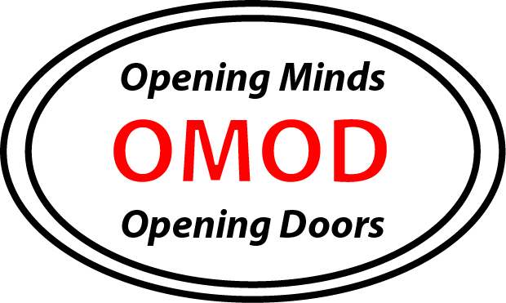

Opening Minds, Opening Doors:
Preparing a Powerful Story for Presentation

Application Deadline: March 13, 2020

Art Spark Texas is seeking adults with disabilities interested in storytelling and public speaking!

Participant Requirements
- Have a disability
- Must be 18 or older
- Demonstrate an interest in writing, public speaking, or advocacy
- Turn in the completed application form (attached)
- Turn in a resume of work and/or volunteer experience (optional)
- Turn in a letter of recommendation (optional)
- Complete a phone interview with a panel of project staff
- Make a suggested donation of $35 to help cover class expenses

Participants in Preparing a Powerful Story for Presentation will be professionally trained to speak and present at statewide conferences. Through a workshop focused on narrative storytelling and presentation techniques, participants will work to develop strong, creative voices and skills to advocate for the disability community.

Workshop Schedule:
6 Saturdays, 1:00-4:00 PM, March 28, April 4, 18 and 25, May 2 and 9
3710 Cedar Street, Austin, TX 78705

Final Showcase:
Sunday, May 10, 1:00-4:00 PM
Location TBD

Note: Attendance is required for all participants unless prior arrangements have been made with the instructor. Reasonable absences due to illness, family emergency, etc. will be excused.
Art Spark Texas: Opening Minds, Opening Doors Application
Due Friday, March 13, 2020 at 5:00 PM

Phone interviews will be scheduled for March 17-23. Final decisions will be announced Tuesday, March 24th.

This application is designed for typing directly into the text boxes. However, the application may also be printed and filled out by hand. Please use extra paper as needed to answer the longer questions. If you have any questions or need assistance to make this form accessible to you, please contact Ms. Boye at boye@artsparktx.org.

Please type answers into the right column. Cells will expand. For “Yes/No” questions, delete the answer you are not using. Please answer every question. If the question does not apply to you, enter “N/A.”

Name
Address
Home Phone
Cell Phone
Email
School Currently Attending
Graduated From
Date of Birth
Accommodations Needed
Dates You Are Not Available
Race/Ethnicity (Optional)
Disability (Optional)
Interest | Writing Yes No  Public Speaking Yes No  Advocacy Yes No
Do You Have Experience With… | Handwriting Yes No  Typing Yes No  PowerPoint /Slideshows Yes No  Microphones Yes No  Theater/Improv Yes No  Email Yes No  Disability History Yes No  Advocacy/Activism Yes No
What Does Being An Advocate Mean To You?

What Topics Or Issues Do You Want To Speak About Publicly?

What Audiences Would You Like To Speak To?

(Audience examples include: parents, high school students, teachers, children, etc.)

Why Should We Choose You To Participate In This Program?

Resume Attached (OPTIONAL) | Yes No
Letter of Recommendation Attached (OPTIONAL) | Yes No
Secondary Contact Person
Relationship
Phone
Email
Submit to Art Spark Texas | Mail: 3710 Cedar Street #7  Austin, TX 78705  Email: boye@artsparktx.org  Fax: 512-454-1944

Art Spark Texas
3710 Cedar Street, Box #7 Room #128
Austin, TX 78705

Local: 512-454-9912
Toll Free: 1-866-489-8412
info@artsparktx.org
www.artsparktx.org

