 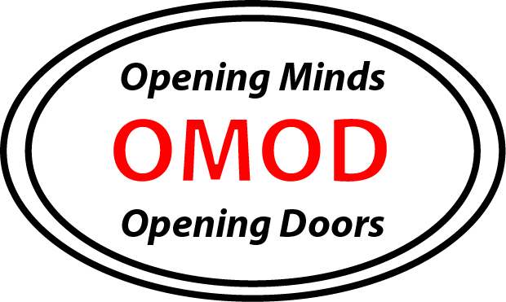

**Opening Minds, Opening Doors:**Health Information and Media Release Authorization

Name: __________________________________________________________

Emergency Contact Person: ________________________________________

Relationship: ________________________ Phone: ____________________

**Health History\***

Please check if participant has any of the following and detail below:

🞎 asthma 🞎 epilepsy 🞎 diabetes 🞎 allergies (food, drug, other)

Or any other medical details the instructor needs to know: ________________________________________________________________

________________________________________________________________

*Health Information is for Art Spark staff purposes only in case of an emergency. *

**Media Release Authorization**

I, ______________________________, hereby grant Art Spark Texas permission to disclose my photograph, video, audio recording, and/or other form of media documentation of my image, voice, **and/or product of my creative expression created in this project/program** for the purpose of sharing with the community the work of Art Spark Texas.  Images and/or audio recordings will appear in publicity pieces including, but not limited to: news releases, publications, videos and web use, photograph, video, audio recording and/or other form of media documentation.

Name: _____________________________________________

Signature: ___________________________ Date:_____________________

Please return to: Art Spark Texas, 3710 Cedar Street #7, Austin, TX 78705