Call For Entries

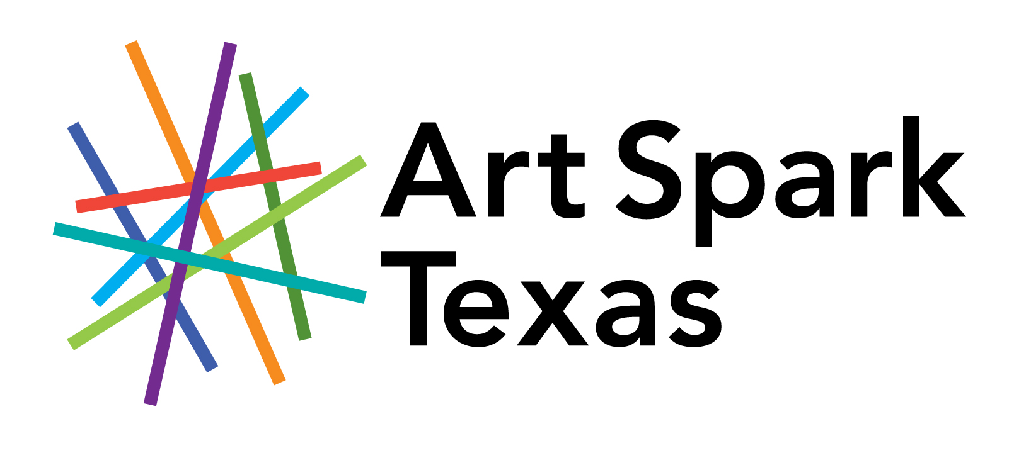

Art Spark Texas
Distinguished Artist Veterans
12th Annual Exhibition – Oct-Nov 2021
DEADLINE: August 31, 2021

Eligibility & Media
Art Spark Texas invites all Veterans and current and prior service members living in Texas to submit artwork to the twelfth annual Distinguished Artist Veterans exhibit. There is no fee to submit artwork to this call for entries and artwork in all 2-D and 3-D media are eligible.

Entries
Please submit up to five entries in the form of photographs or digital images by email. Entries must include the attached entry form. Please label each photograph or digital image to match a corresponding piece on the form. The deadline for entry is August 31, 2021. Those selected will be notified by September 22, 2021 and must ship or deliver to arrive by October 2, 2021. Shipping/delivery instructions will be provided upon acceptance. All artwork sales will be subject to a 40% commission.

Exhibition & Reception
The exhibit will be on display at the Hive by the Bee Cave Arts Foundation. The exhibition will run from October 8 – December 3, 2021. An opening reception will be held on Friday, October 8th from 6-8 pm. A free visual art workshop for all participating artists is also being planned.

Terms
An entry to this exhibit constitutes full agreement on the part of the artist to all conditions outlined in this call for entries.
* The Exhibit Committee will have final authority to define what constitutes an acceptable entry.
* If framed, work must be strongly framed and wired ready for hanging. NO sawtooth hangers.
* Artwork may be photographed by the organizers for publicity purposes.
* Artwork will not be covered by insurance during the exhibition. Art Spark Texas and The Hive will not be liable for loss or damage of work.
* Interested buyers may be directed to Art Spark Texas and a 40% commission on all sales will be split among Art Spark Texas and The Hive.

Calendar
August 31, 2021 Entry deadline
September 22, 2021 Notification of acceptance
October 2, 2021 (3-5 pm) Accepted works due
October 8, 2021 (6-8 pm) Opening Reception
TBA Free Artist Workshop
December 3, 2021 Closing of Exhibition
December 4, 2021 Artwork Pickup

ALL ENTRIES MUST BE SUBMITTED TO:
April Sullivan, Artworks Director
BY MAIL: Art Spark Texas 3710 Cedar Street #7, Austin, TX 78705
BY EMAIL: april@artsparktx.org OR BY FAX: 512-454-1944
For further information contact April Sullivan at 512-454-9912 or april@artsparktx.org
ENTRY FORM
2021 Distinguished Artist Veterans

Name:
Address: City/State/Zip:
E-Mail: Telephone:
Social Media Pages or website:
Branch of Service/Dates served:

Entry #1

Title: Year Created:

Medium Price: Framed size:
Entry #2

Title: Year Created:

Medium Price: Framed size:

Entry #3

Title: Year Created:

Medium Price: Framed size:

Entry #4

Title: Year Created:

Medium Price: Framed size:

Entry #5

Title: Year Created:

Medium Price: Framed size:

Please accept my work for consideration in the Art Spark Texas Twelfth Annual Distinguished Artist Veterans Exhibition. By applying to this exhibit, I agree and submit to all the terms outlined in the call for entries.

Artist Signature: Date:

